Talking to the police

A guide to explain your rights when talking to the police.
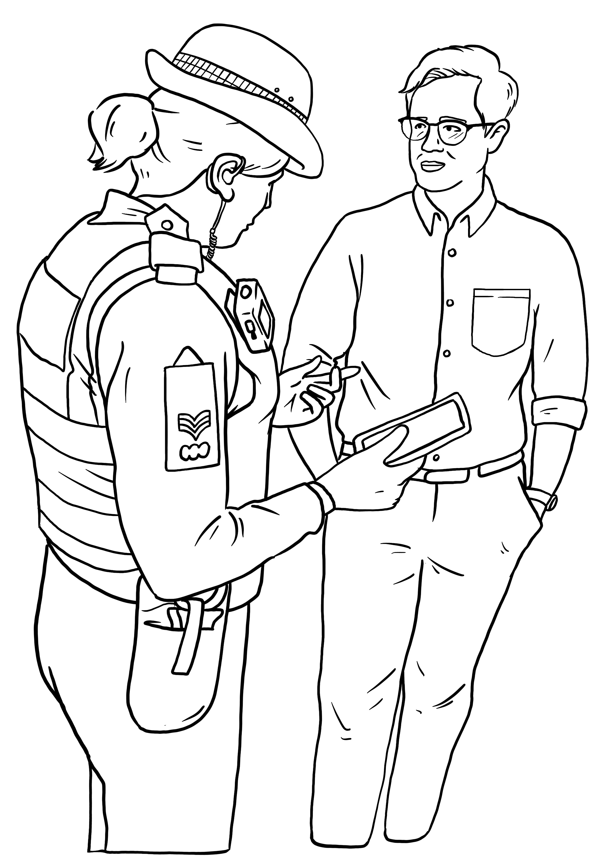
Brought to you by Liberty and Include.org. Images by Change People.
This guide explains your rights when talking to the police.
Big words are in bold writing. There is a list of big words at the end. It explains what these words mean.

Section 1: Can the police ask me questions on the street?
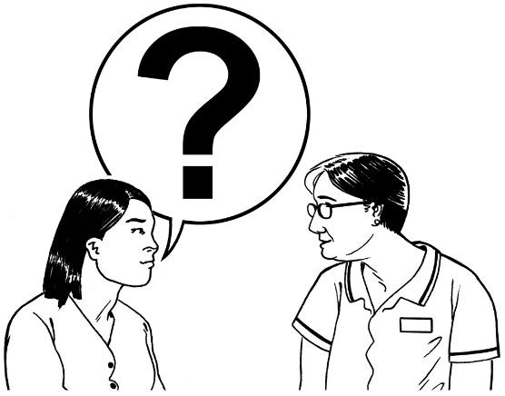 | Anyone can ask you a question.  The police can ask you questions.
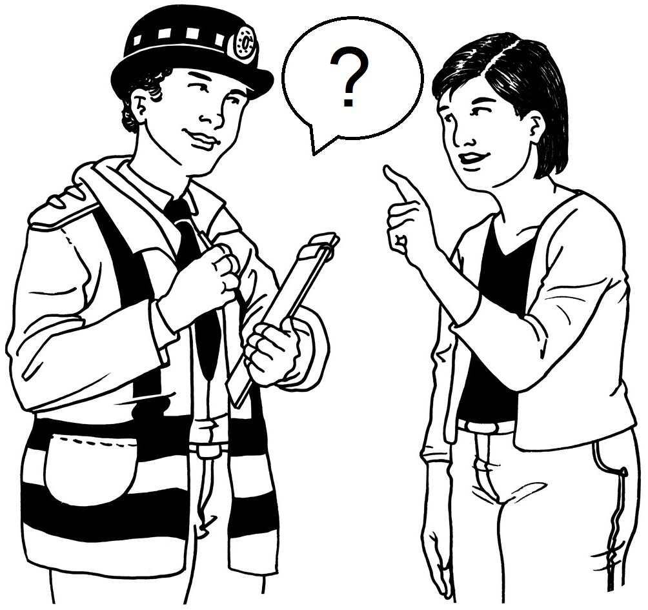 | If a police officer asks you questions, that does not mean you have done anything wrong.
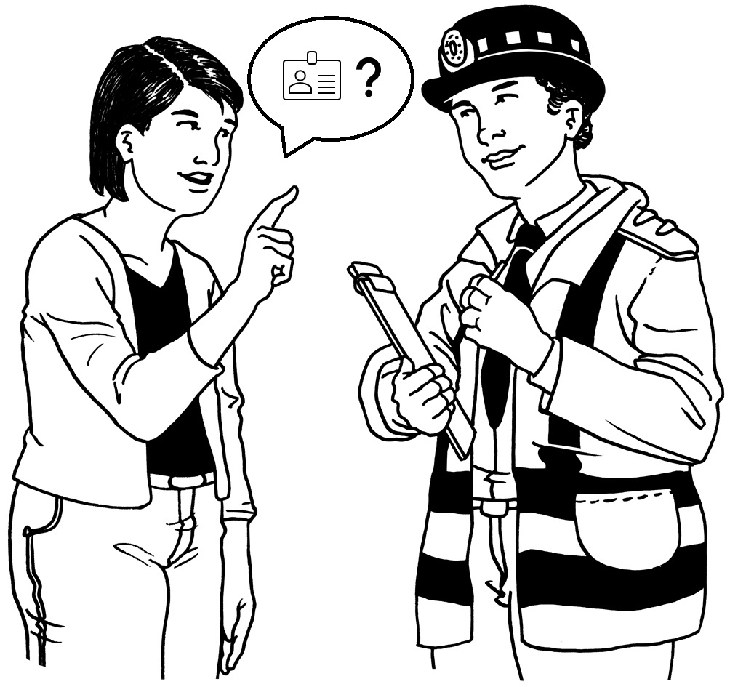 | You should always ask to see a police officers’ ID.  ID shows you who the officer is.

Section 2: do I always have to answer police questions?
 | No, you do not always have to answer police questions.  You have a choice.
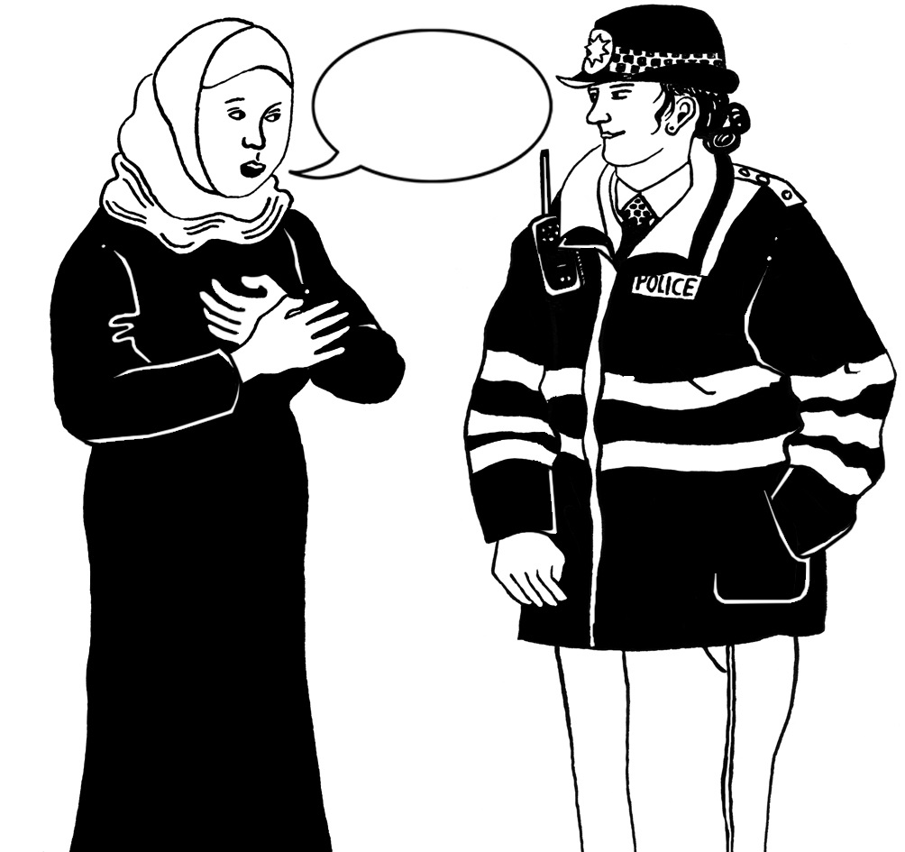 | You can choose to talk.
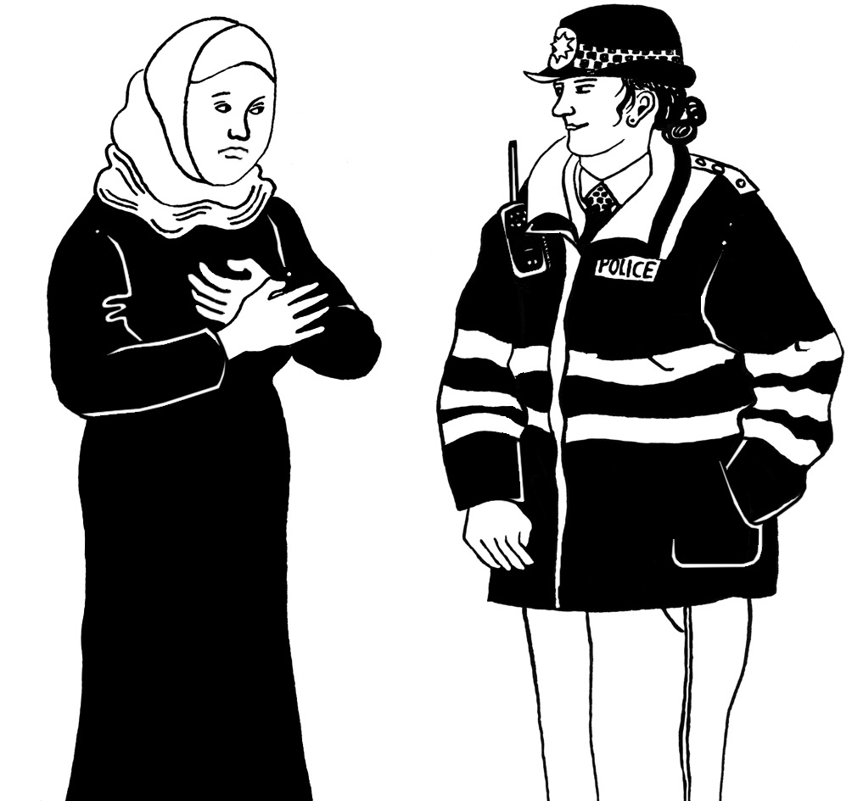 | You can choose to not talk.

Section 3: why would the police want to speak to me?
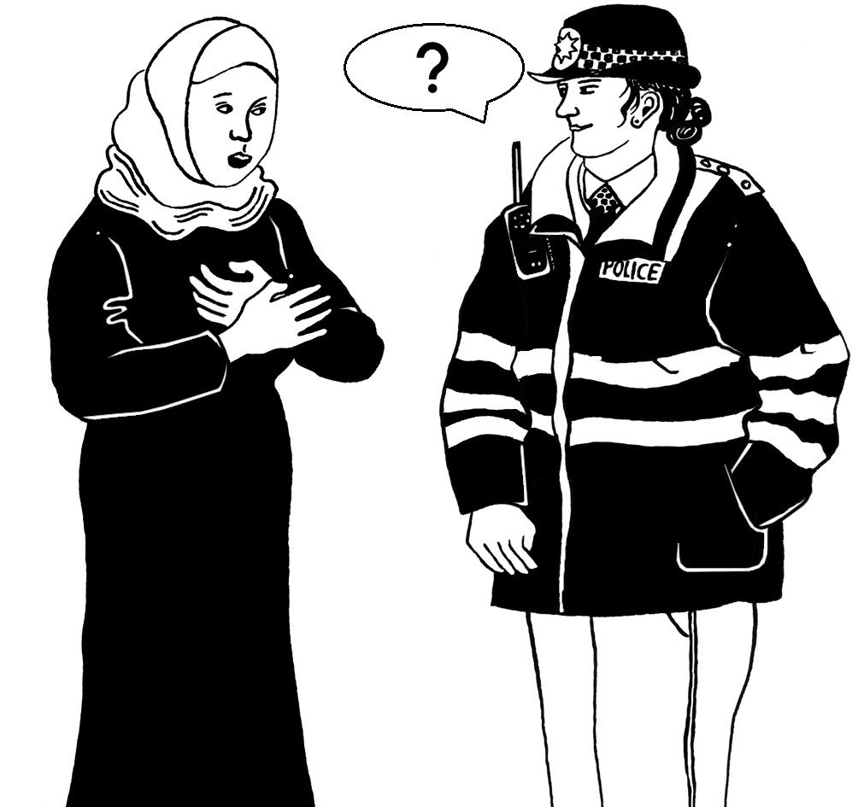 | The police may want to speak to you for different reasons.
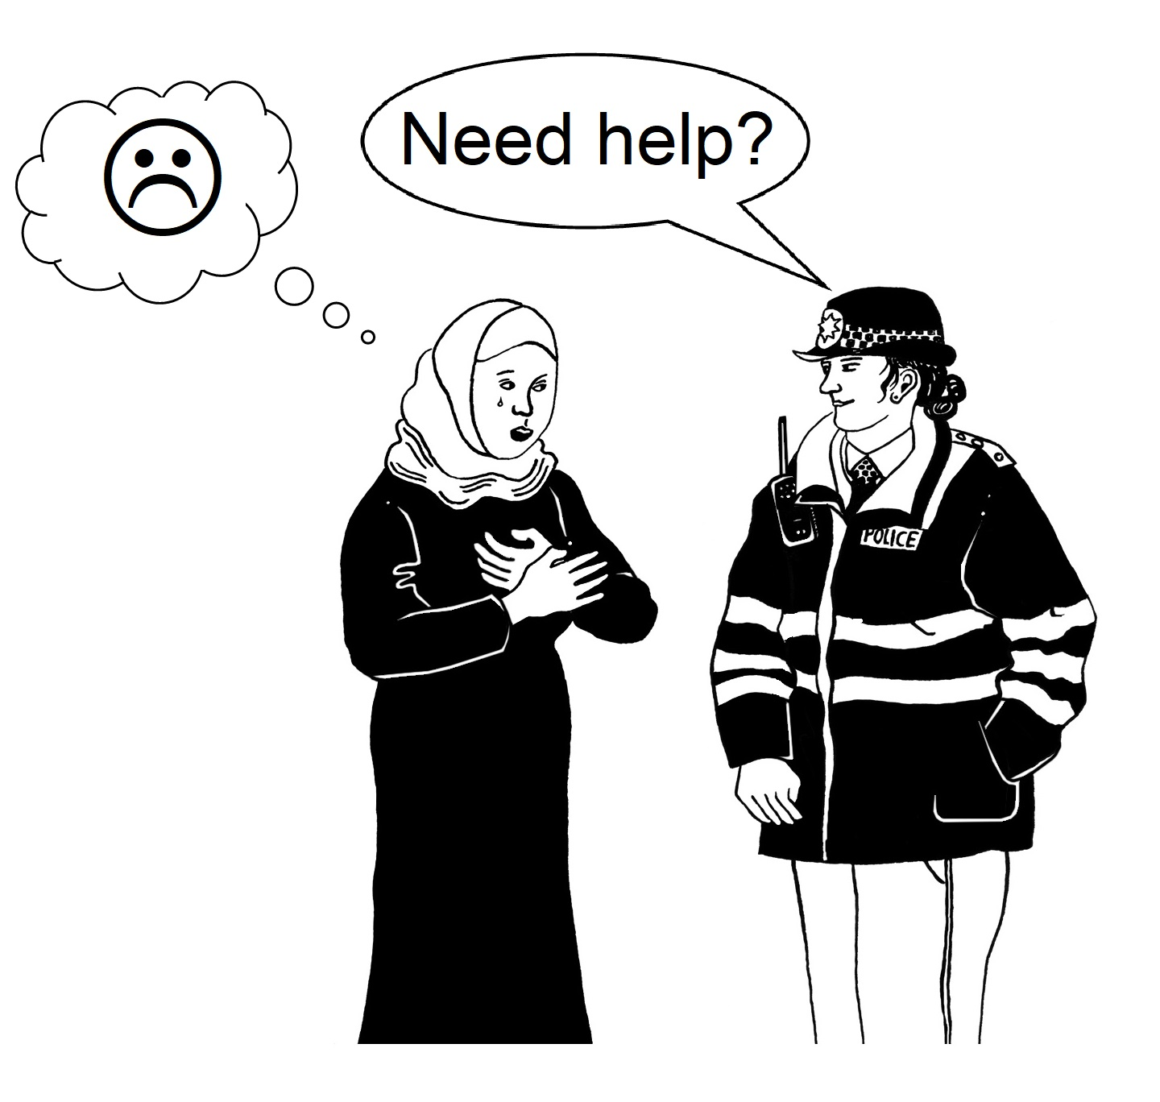 | Police may want to speak to you because you need help
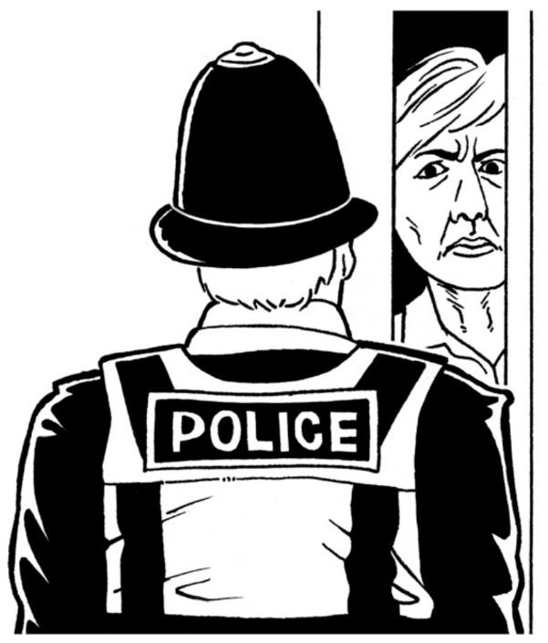 | Police may want to speak to you because they think you did something wrong.
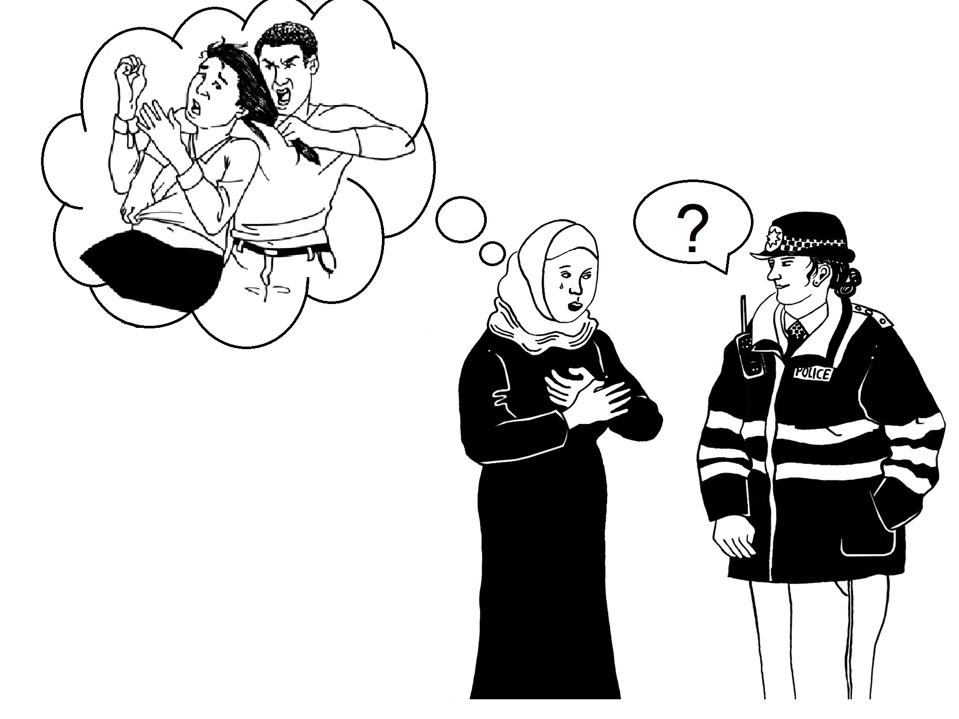 | Police may want to speak to you because they think you saw a crime.
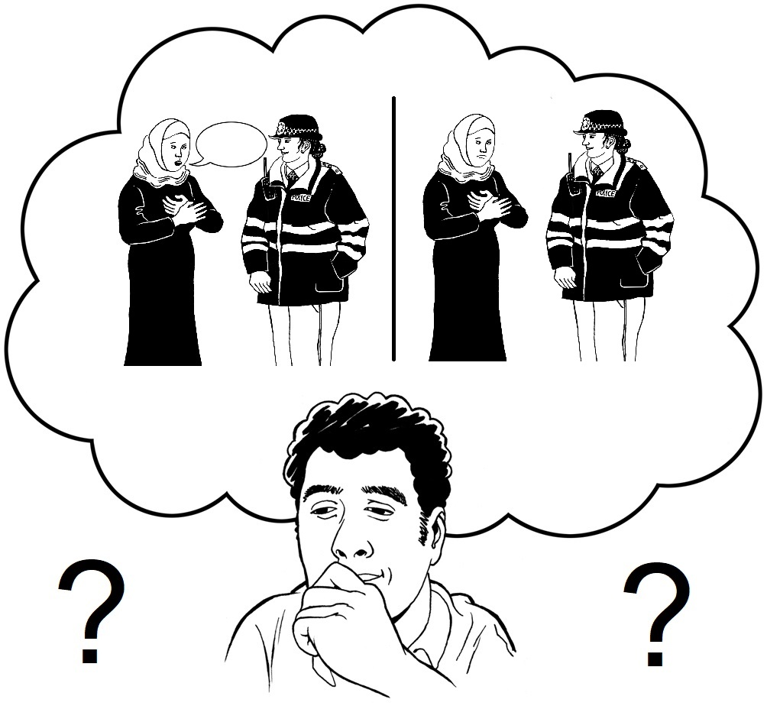 | You have a choice to talk to the police or not.

Section 4: Seeing (witnessing) a crime and answering questions
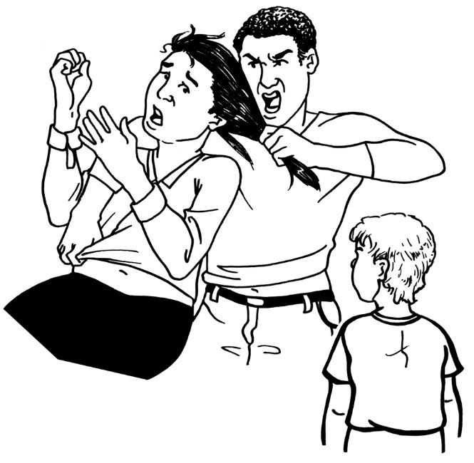 | A witness is someone who sees a crime happening.  A crime is when someone breaks the law.  If you see a crime, you are a witness.
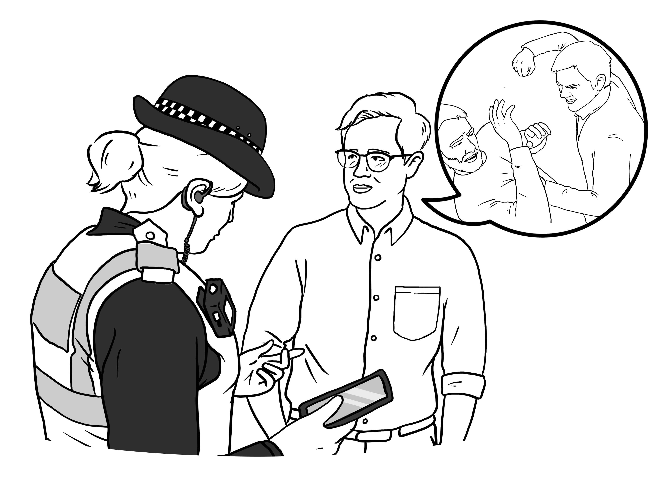 | Sometimes the police want to ask witnesses about what they saw.  They will ask to speak to the witness.  This is called a witness interview.
 | You have a choice to talk to the police or not.

Section 5: witness interviews at the police station
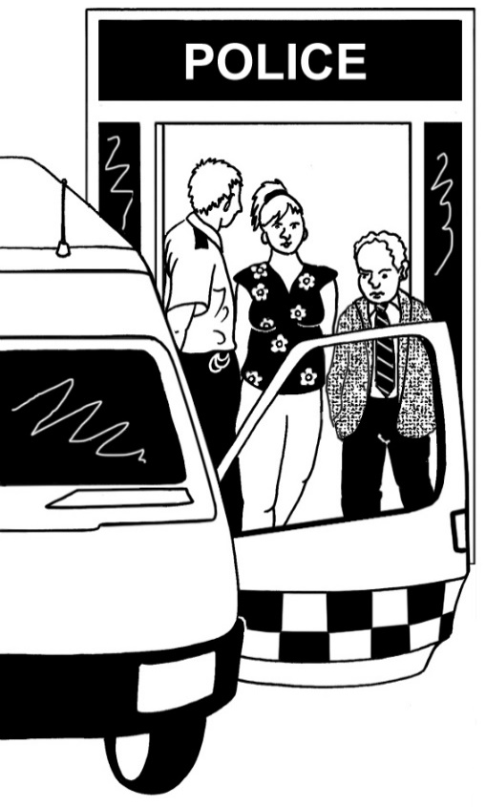 | The police can ask to take you to a police station to do the witness interview.  A witness interview is when the police ask you questions because you saw a crime.
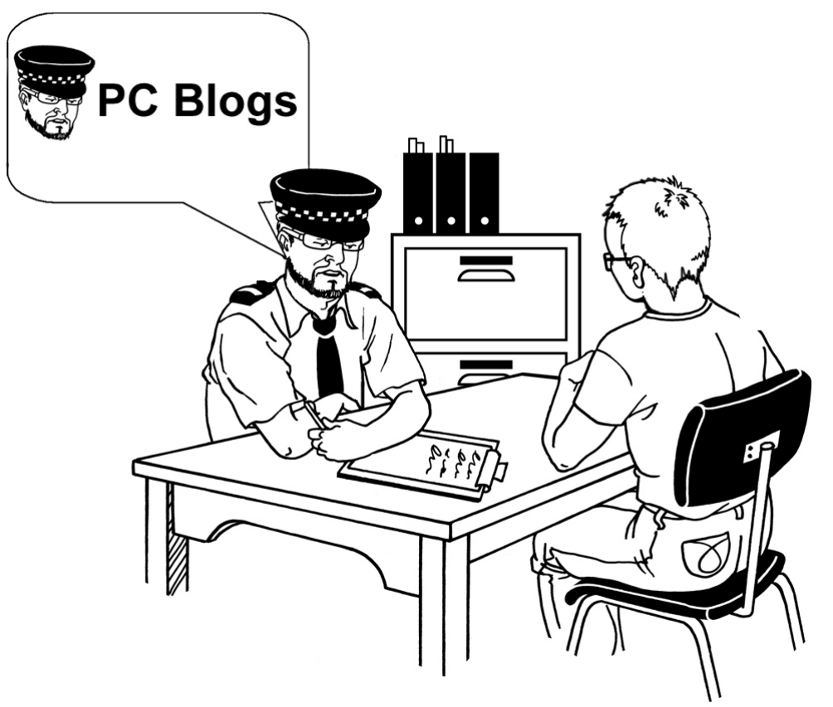 | If you go to the police station, the police can interview you.  This is when the police ask you questions about what you have seen.
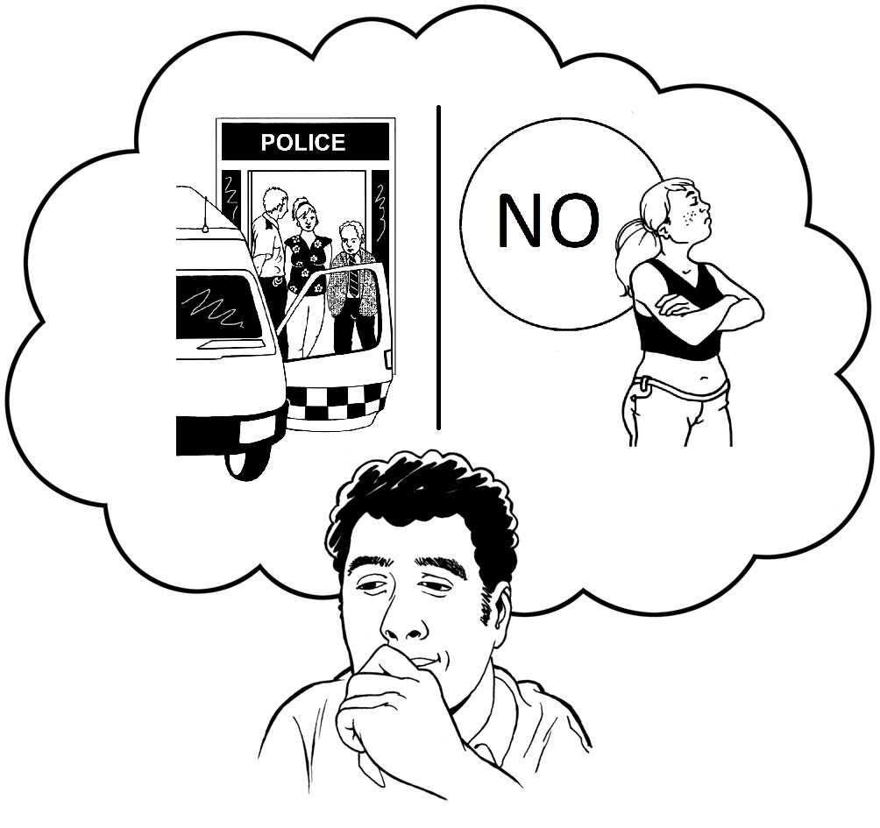 | You can choose.  You can go to the police station if you want to.  You do not have to go to the police station.

Section 6: Being a suspect and answering questions
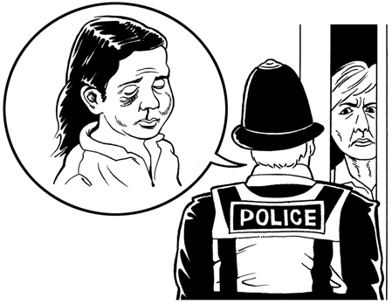 | A suspect is someone who the police think has broken the law.
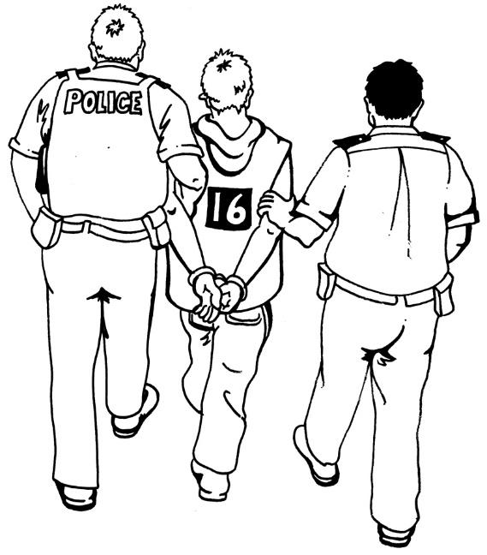 | If you are a suspect, you don’t have to talk to the police.  Different things can happen if you are a suspect.  What happens depends on what the police believe you have done.

Section 7: Stop and search and answering questions
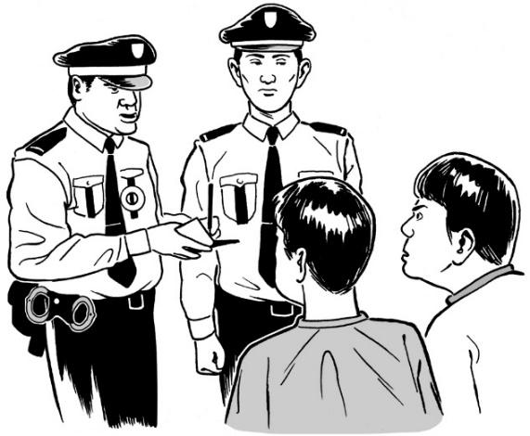 | Sometimes the police can stop you to see what you have.  Police can stop you if they think you have something that can hurt someone (dangerous) or something against the law (illegal).
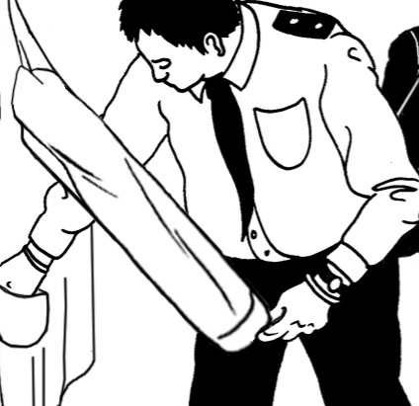 | Stopping you to see what you have is called stop and search.  The police can search you.  They will check your clothes to see what you have.
 | You have to stay while the police search you, but you don’t have to say anything.

Section 8: Antisocial behaviour and answering questions
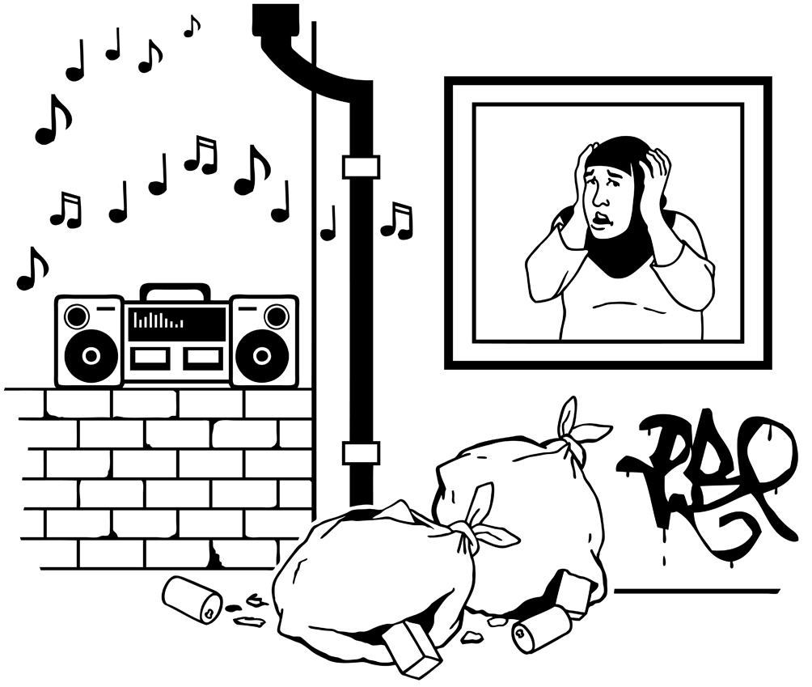  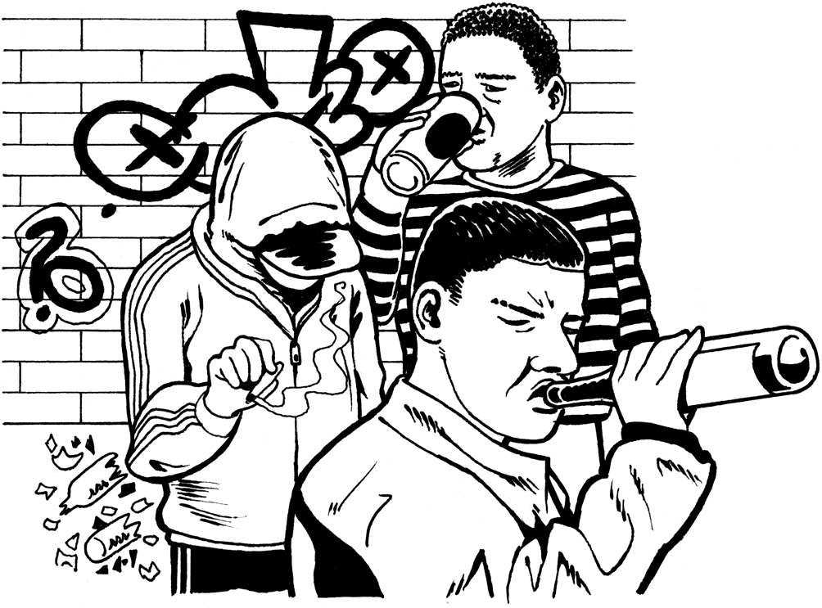 | Behaving in an antisocial way means you are making someone else feel very worried or scared.
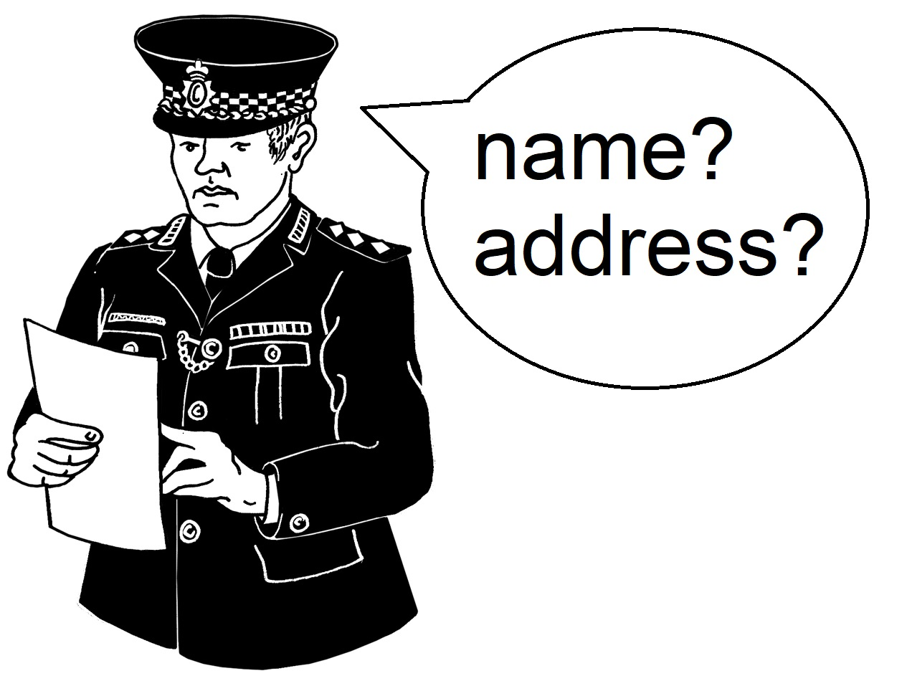 | The police can ask your name and address if they think you are behaving in an antisocial way.
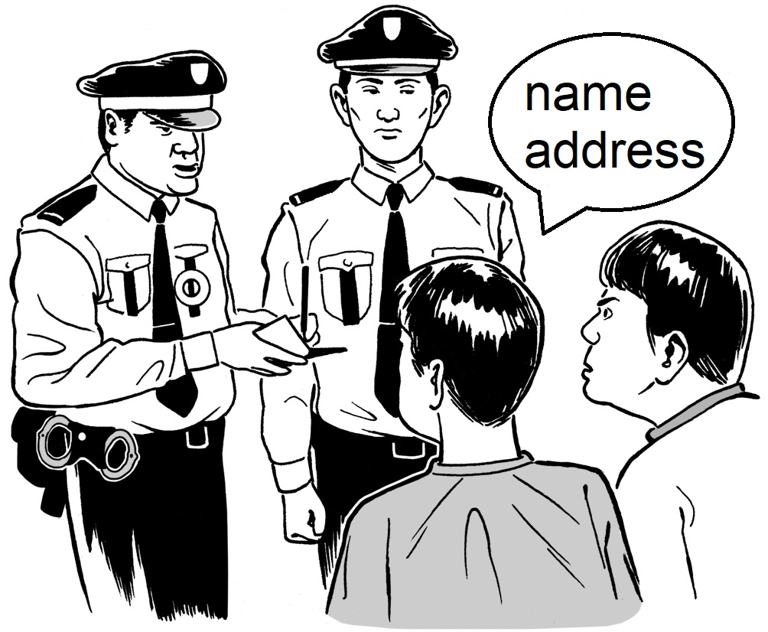 | You do have to tell the police your name and address if the police believe you are acting in an antisocial way.
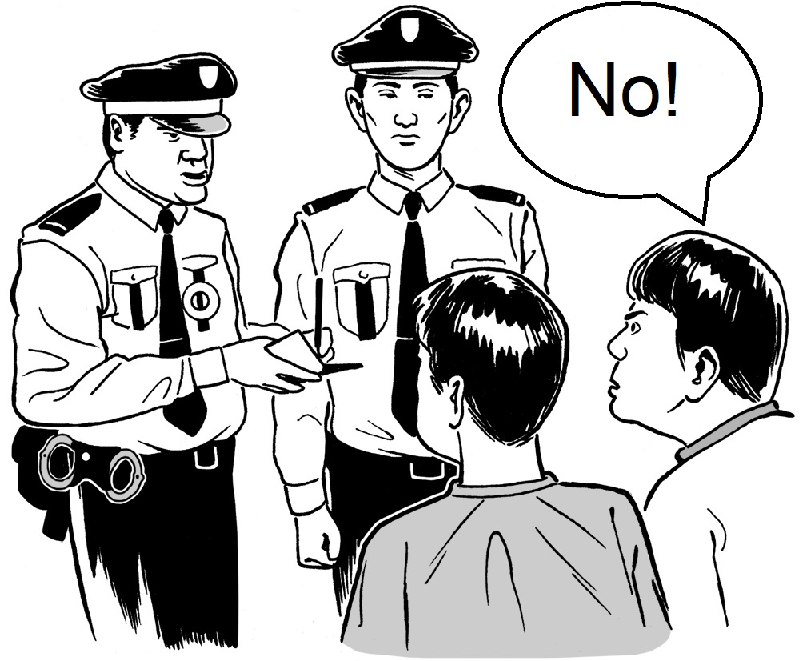  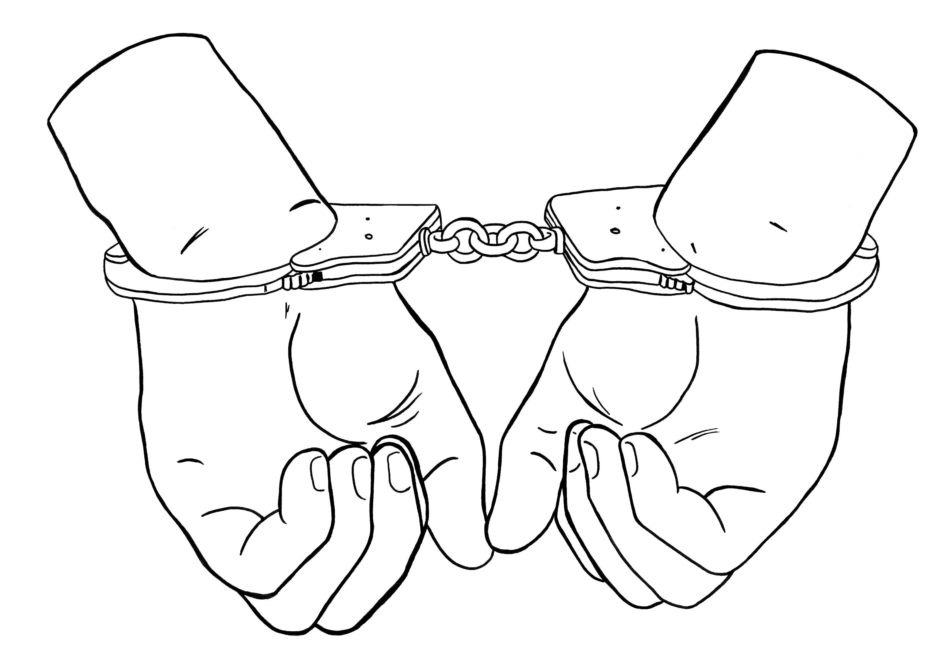 | It’s a crime if you behave in an antisocial way and you don’t tell the police your name and address.
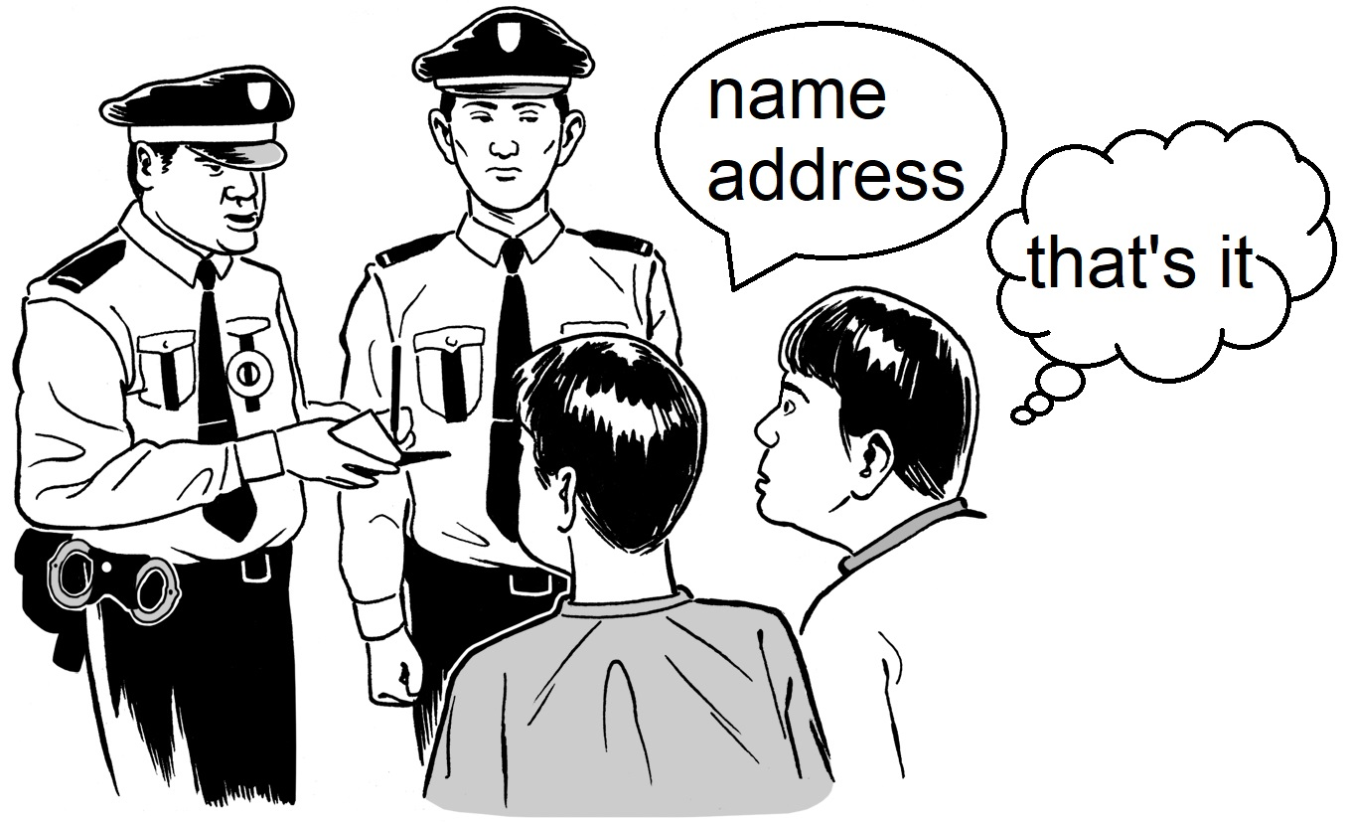 | You only have to tell the police your name and address.  You don’t have to say anything else.

Section 9: Being arrested and answering questions
Arrest is when the police take you to the police station.

The police can arrest you if they believe you have broken the law.

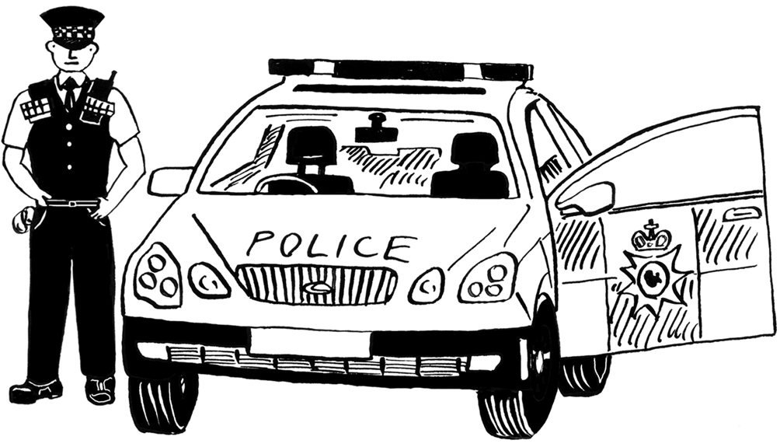 | If you are arrested, you have no choice.  You must go with the police.
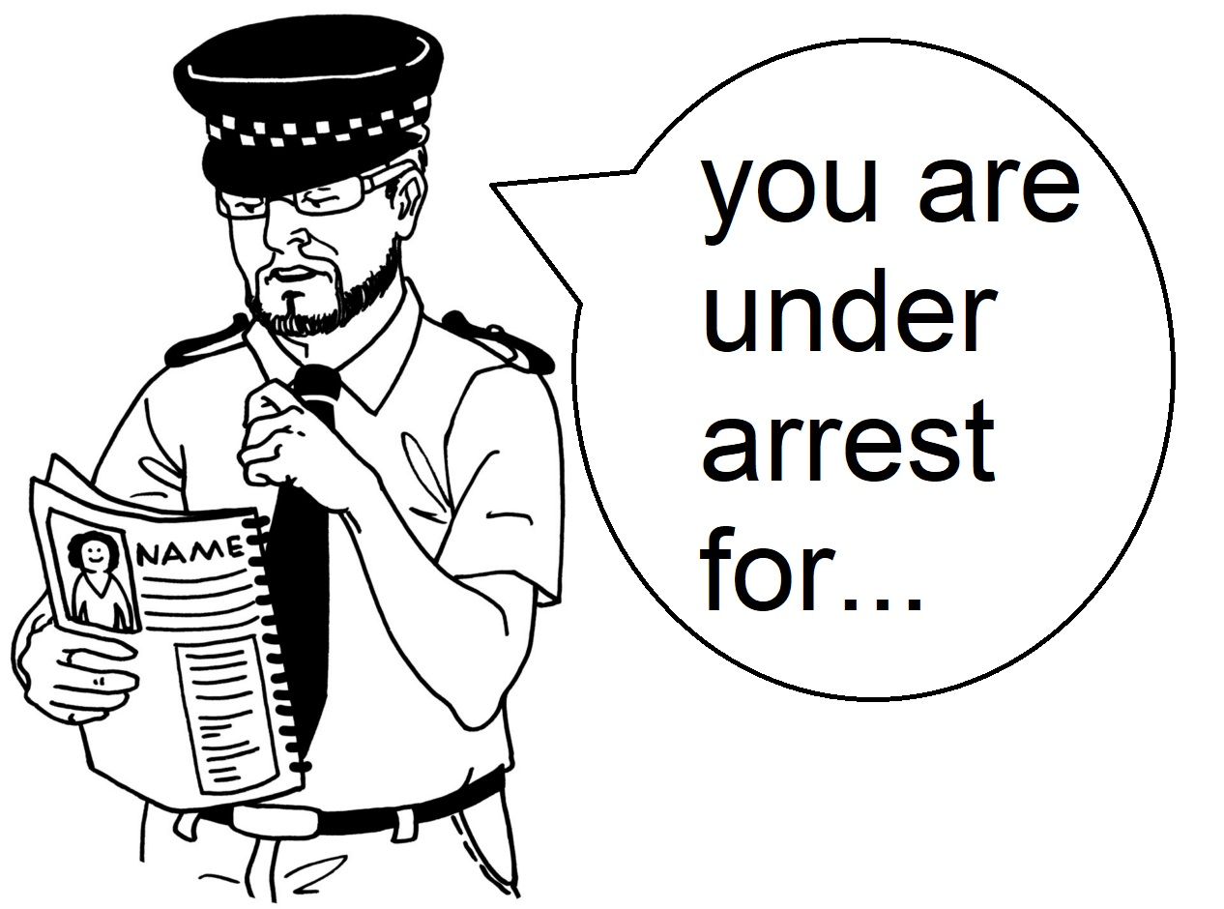 | The police must tell you that they are arresting you.  The police must say why they are arresting you.
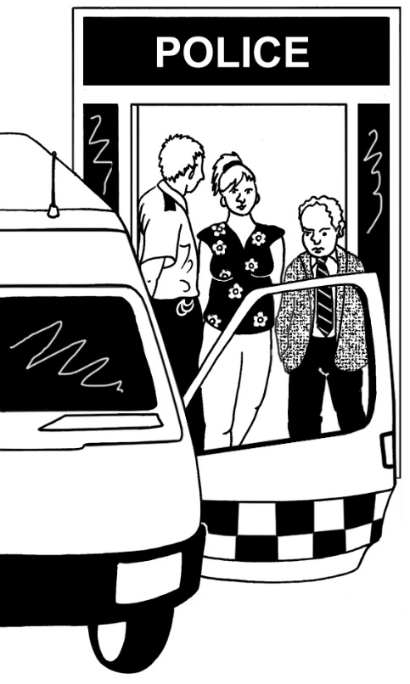 | If you are arrested, the police will take you to the police station.
 | You do not have to talk to the police on the way to the police station.

Section 10: Caution on arrest
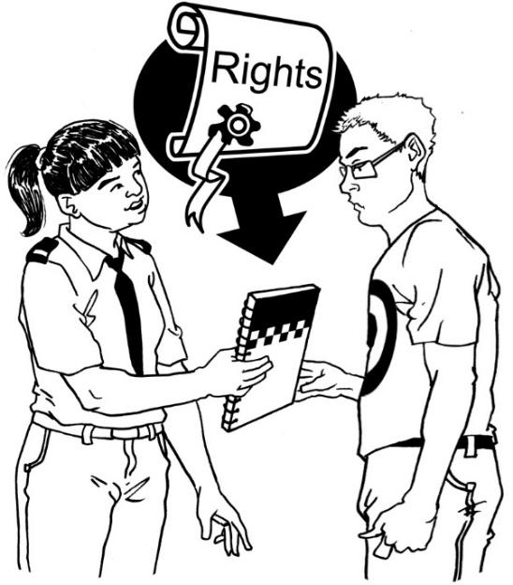 | If the police think you have broken the law, they must tell you that you have rights.  Rights are things you must be given.
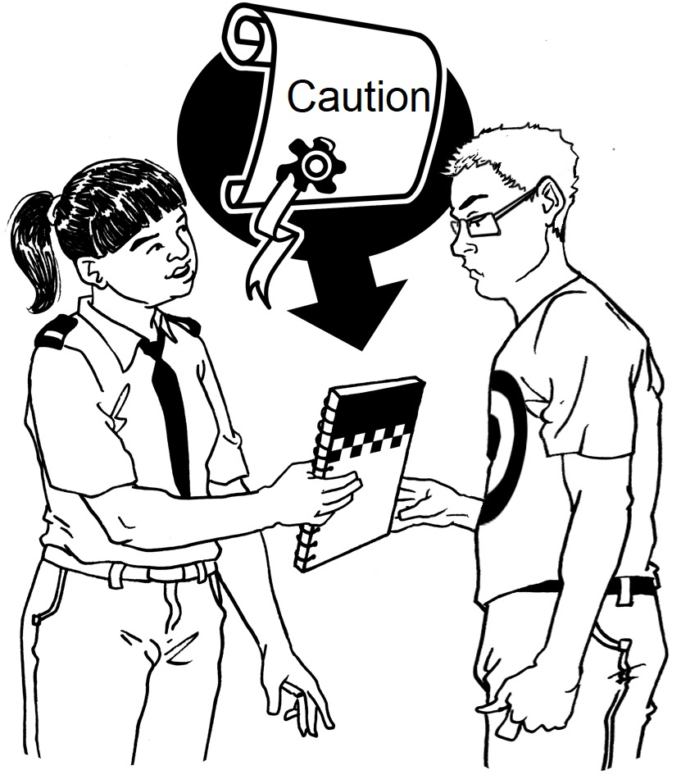 | Telling you your rights after you’re arrested is called reading you a caution.
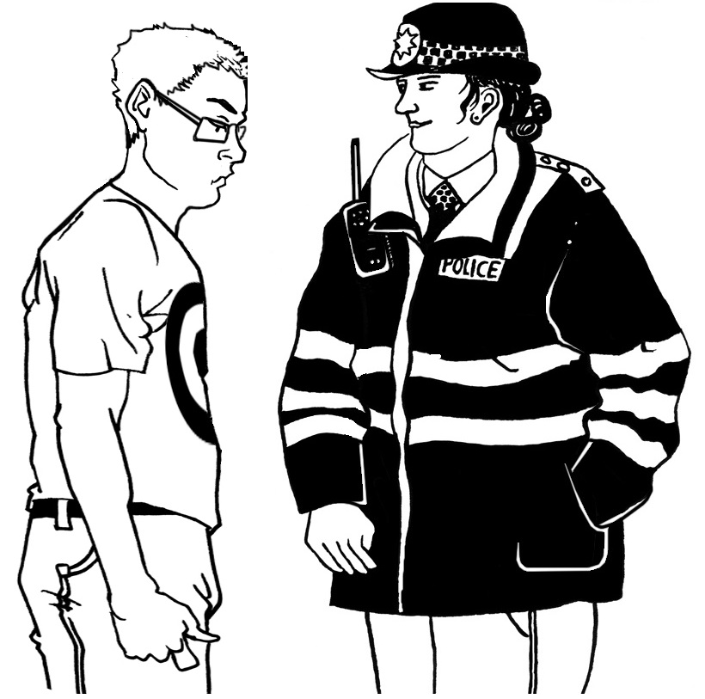 | It means you don’t have to say anything about what the police think you have done.

Section 11: interview under caution
At the police station, the police will ask you about what you did.

This is called an interview under caution.

The police must read the caution to you first. The police must tell you your rights.

Then they can interview you.
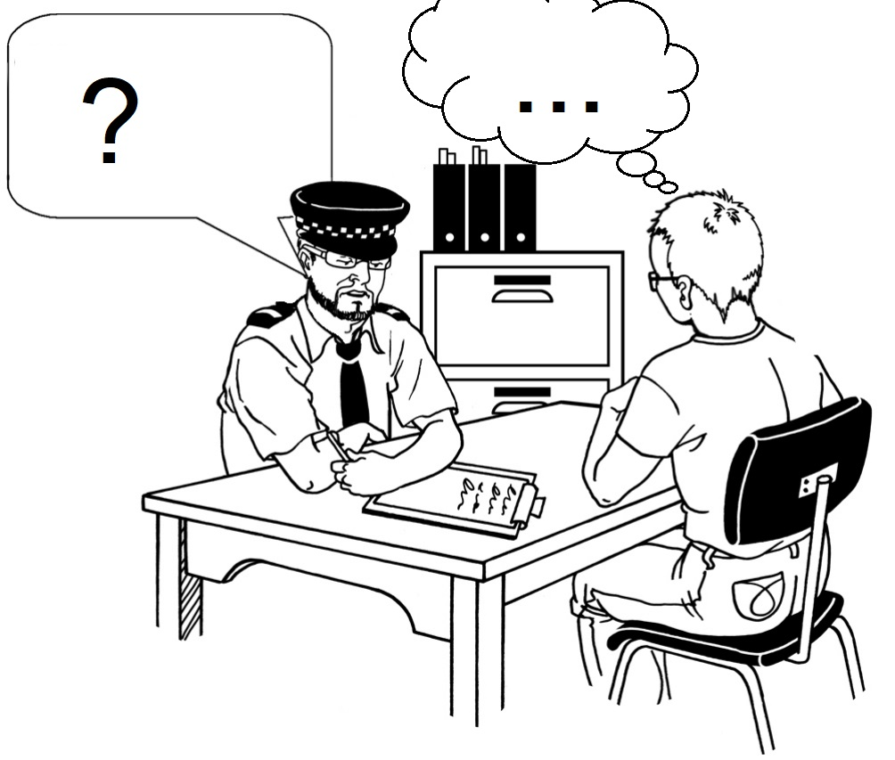 | You do not have to say anything in the interview under caution.

Section 12: your rights if you are arrested
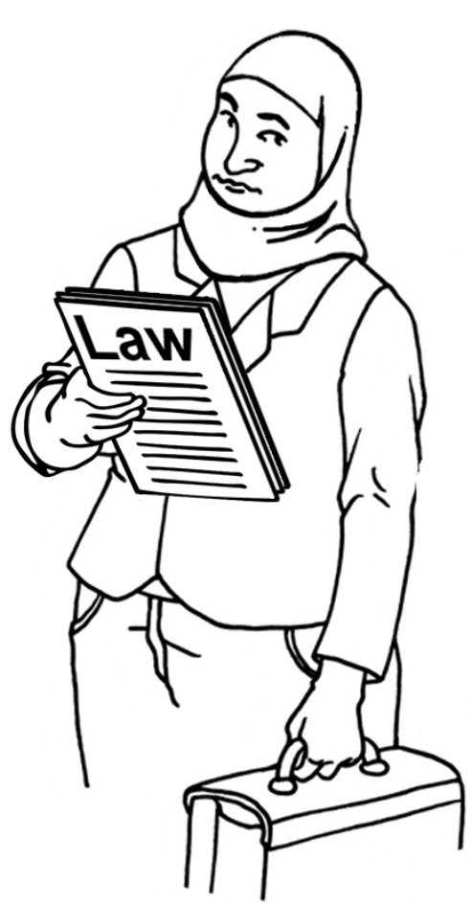 | You have the right to speak a solicitor before the interview if you are arrested.  A solicitor tells you about your rights.
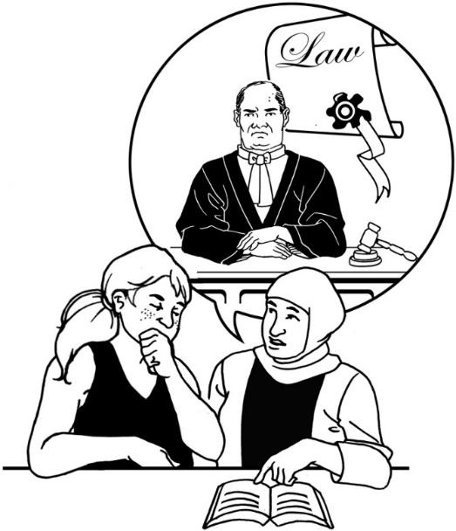 | If you are arrested, it’s good to speak to a solicitor before you speak to the police.
 | You have lots of other rights at a police station.  You can read more by scanning this code with a phone camera.

List of words
Antisocial: acting in a very unkind way, making people feel scared and unsafe
Arrest: if police stop you and take you to a police station because they think you’ve done a crime.
Behaviour: the way a person acts
Caution: when the police tell you what rights you have if you are arrested
Crime: when we do something wrong and break the law
Dangerous: something that can hurt someone
ID: tells you who someone is.
Illegal: something that is against the law and not allowed.
Interview: when someone asks you a lot of questions to find out something
Interview under caution: when you are arrested and the police ask you a lot of questions after telling you your rights
Law: rules that tell us what we can and can’t do. It helps everyone live together in a society.
Police station: where the police officers work and speak to members of the public.
Right: a right something you have because of a law. It means that other people have to do something for you or give you something.
Solicitor: a lawyer who tells you about your rights
Stop and search: when the police stop you because they think you broke the law. They check to see what you’re carrying.
Suspect: someone the police think has broken the law
Witness: someone who sees a crime happen

Liberty Advice and Information
March 2024

Thank you Include.org champions!
You helped make this guide.
Liberty is very grateful for your help!

Do you have questions about this guide?
Contact Liberty’s Advice and Information team
by scanning the QR code below:


