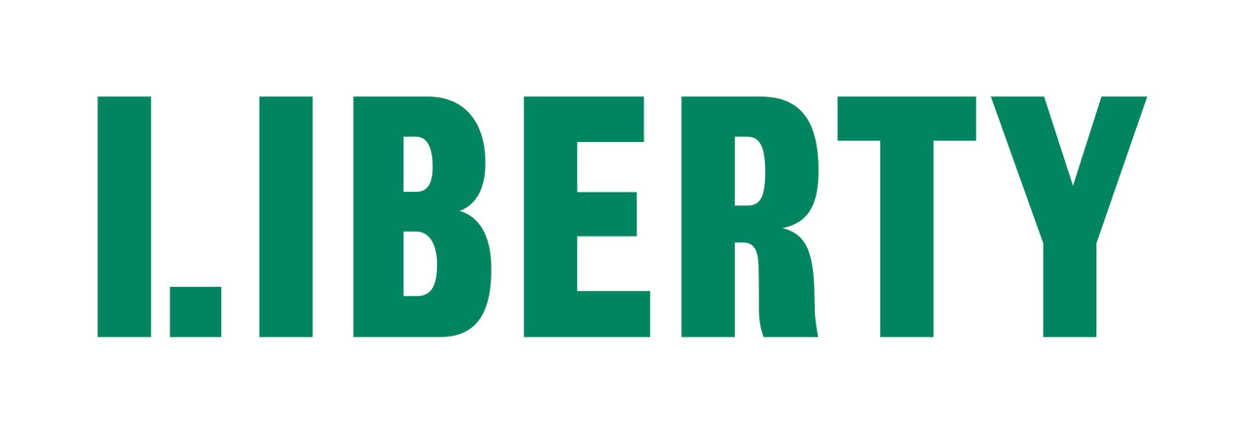
RECRUITMENT PACK: DIGITAL CONTENT ASSISTANT
Liberty is an independent membership organisation. We challenge injustice, defend freedom and campaign to make sure everyone in the UK is treated fairly.
We are campaigners, lawyers and policy experts who work together to protect rights and hold the powerful to account. We empower others to defend their own rights and the rights of their family, friends and communities.
Our principles are guided by evidence and expertise – not political agenda, profit or popular opinion. We’re not afraid to speak uncomfortable truths or confront intolerance and abuse of power wherever we find it.
Together we’ve been making the UK a fairer, more equal place since 1934.
POSITION DESCRIPTION
Position title: | Digital Content Assistant
Team: | Communications
Employment status: | Fixed-term, 12 months
Salary: | £31,355.27
Hours: | 35 hours per week plus occasional out of hours work
Location: | Liberty House, London or remote
Closing date for applications: | 9am Monday 27 June 2022
Interview dates: | First round: Week commencing 11 July.  With the possibility of second round interviews the following week

ROLE PURPOSE
We’re looking for a creative communicator with a flair for content creation to join our fast-paced communications function.

This role will support the team to deliver cut-through content across our digital channels primarily to support our Human Rights Act campaign #SaveYourRights, as well as other priority areas.

You will support the wider team in strengthening Liberty’s social media presence, making improvements to our website and helping ensure our day-to-day comms runs smoothly.

This is an ideal position for a someone with excellent attention to detail and experience of content creation and editing, and a passion for social justice.

KEY RESPONSIBILITIES
- Work alongside the Digital and Design Assistant to develop, edit and upload content to our website and social media channels, with a focus on the Human Rights Act and our #SaveYourRights campaign
- Work closely and collaboratively with Liberty’s Policy & Campaigns Team to support the delivery of the #SaveYourRights campaign
- Liaise with campaign partners and stakeholders in the development and launch of #SaveYourRights campaign materials and digital assets
- Support the Digital and Design Assistant to develop a proposal for how Liberty might launch on Tik Tok, with emphasis on #SaveYourRights
- Assist in the monitoring and evaluation of social media and web analytics.
- Assist in the management and maintenance of Liberty’s image library.
- Work with Digital Manager on maintaining and developing all of Liberty’s digital products, including email broadcast software, member and supporter campaign actions, online fundraising in Engaging Networks and online Advice & Information hub.
- Research digital trends, developments and best practice.

- Support the wider team’s work i.e., media relations on #SaveYourRights as well as other key campaign areas for Liberty
- Attend Liberty events as needed, including occasional duties outside of office hours.
- Maintain an awareness and knowledge of developments in human rights and civil liberties in the UK.

SELECTION CRITERIA |  | ESSENTIAL | DESIRABLE
EXPERIENCE & KNOWLEDGE: | Excellent IT skills (including proficiency in Microsoft Office)
 | Experience of designing creative social media content and marketing materials
 | Experience of working on a regularly updated website
 | Experience of video editing
 | Strong attention to detail
COMPETENCIES & SKILLS: | Creativity: Ability to think and work creatively
 | Proactive delivery: Ability to manage competing priorities and work independently to meet deadlines and solve problems
 | Collaboration: Ability to develop and maintain internal and external working relationships, including at senior level, and to be a positive member of the team.
 | Communication: Strong visual and written communication skills
VALUES | Commitment to upholding and advocating for Liberty’s values both internally and in our external communications
 | Commitment to building a fair, compassionate and diverse working environment
 | Commitment to and understanding of Liberty’s broad campaigning objectives

IMPORTANT INFORMATION
- Application forms should be returned by email as Word or PDF documents to HR@libertyhumanrights.org.uk with the job title as the subject no later than 9am Monday 27 June 2022
Applications received after the closing date will not be considered.
We also ask you to submit the diversity monitoring form, available from our website, but this is optional.
- You will receive an automatically generated response confirming receipt. If you DO NOT receive this response within one to two hours of sending, please call 020 7403 3888 to check whether your application has been received - be sure to do so before the closing date.
- First round interviews are scheduled for the week commencing Monday 11 July 2022, with the possibility of a second round the following week. Shortlisted applicants will be contacted to arrange interview times. Details of the interview (location, members of panel etc) will be confirmed by email.
- Applicants who have not been short listed will be notified by email. Due to our limited resources, we are unable to provide feedback on applications.
- Interview panels will be made up of two to four people who will each ask the candidates questions. The questions are intended to allow you to expand on your application and to demonstrate to the panel how far you meet the essential and desirable requirements of the post. All candidates are asked a uniform set of questions (usually 5 or 6) and may also be asked follow up questions to clarify or expand on individual answers. At the end of the interview candidates will also have an opportunity to ask questions about the job, conditions of service, etc.
- Shortlisted candidates may be asked to complete pre-interview tasks.
- Once all interviews have taken place, shortlisted applicants will be contacted and informed of the outcome either by email or phone and offered the opportunity to receive feedback.
- If you have a special requirement for completing the interview or a task remotely due to an impairment or connectivity reasons, please contact us on 020 7403 3888.

