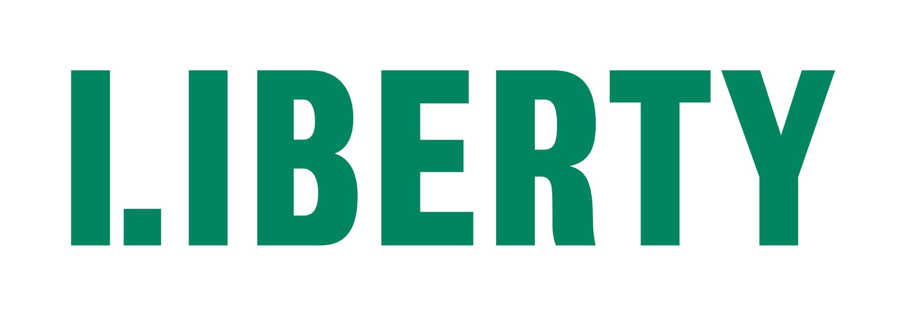
RECRUITMENT PACK: DIGITAL AND DESIGN ASSISTANT
Liberty is an independent membership organisation. We challenge injustice, defend freedom and campaign to make sure everyone in the UK is treated fairly.
We are campaigners, lawyers and policy experts who work together to protect rights and hold the powerful to account. We empower others to defend their own rights and the rights of their family, friends and communities.
Our principles are guided by evidence and expertise – not political agenda, profit or popular opinion. We’re not afraid to speak uncomfortable truths or confront intolerance and abuse of power wherever we find it.
Together we’ve been making the UK a fairer, more equal place since 1934.
POSITION DESCRIPTION
Position title: | Digital and Design Assistant
Team: | Communications
Employment status: | Permanent
Salary: | £31,851
Hours: | 35 hours per week plus occasional out of hours work
Location: | Liberty House, Westminster, London
Closing date for applications: | 9am Wednesday 09 February 2022
Interview dates: | First round: Week commencing 21 February.  With the possibility of second round interviews the following week

ROLE PURPOSE
We are looking for a creative and committed digital and design assistant who is keen to build experience of working in a fast-paced campaigning communications team.

You will play a key part in translating Liberty’s message into stand-out digital, video and print materials and making sure digital content is integrated into our wider communications.

You will primarily support Liberty’s Digital Manager in maintaining, developing and evaluating our online and on social media presence. You will also work closely with the Communications Officer on offline design and print materials for Liberty.

This would be an ideal position for a creative individual with excellent design skills, an understanding of developments in digital communications and a passion for social justice and campaigning.

KEY RESPONSIBILITIES
SUPPORTING LIBERTY’S DIGITAL PRESENCE

- Support the delivery of Liberty’s campaigning and communications goals by recommending and creating shareable social media content. This includes
  - Creating graphics for social media (twitter, facebook and Instagram)
  - Working with the Digital manager and Communications assistant to produce, edit and distribute videos for social media
  - Clipping and captioning media appearances of Liberty spokespeople
- Update, edit and upload content to Liberty’s website.
- Assist in the monitoring and evaluation of social media and web analytics.
- Assist the Digital Manager in the delivery of website enhancements.
- Assist in the management and maintenance of Liberty’s image library.
- Assist in planning, production and distribution of external video content production.
- Work with Digital Manager on maintaining and developing all of Liberty’s digital products, including email broadcast software, member and supporter campaign actions, online fundraising in Engaging Networks and online A&I hub.
- Manage Liberty’s Instagram channel.
- Research digital trends, developments and best practice.

WIDER TEAM SUPPORT

- Work with Liberty’s Communications Team to ensure ideas for creative digital content are fed into communications plans.
- Work closely with Communications Officer and colleagues across Liberty to co-ordinate internal and external design and print projects.
- Lead on design of in-house produced print materials
- Attend Liberty events as needed, including occasional duties outside of office hours.
- Maintain an awareness and knowledge of developments in human rights and civil liberties in the UK.

SELECTION CRITERIA |  | ESSENTIAL | DESIRABLE
EXPERIENCE & KNOWLEDGE: | At least one year’s experience in digital communications or a closely related role
 | Excellent IT skills (including proficiency in Microsoft Office and CMS)
 | Experience of designing creative social media content and marketing materials
 | Experience of working on a regularly updated website
 | Proficiency in use of design software such as InDesign and Photoshop
 | Experience of video editing
 | Basic knowledge of HTML
COMPETENCIES & SKILLS: | Communication: Strong visual and written communication skills
 | Creativity: Ability to think and work creatively
 | Proactive delivery: Ability to manage competing priorities and work independently to meet deadlines and solve problems
 | Excellent attention to detail
 | Collaboration: Ability to develop and maintain internal and external working relationships, including at senior level, and to be a positive member of the team.
VALUES | Commitment to and understanding of Liberty’s broad campaigning objectives
 | Commitment to building a fair, compassionate and diverse working environment

IMPORTANT INFORMATION
- Application forms should be returned by email as Word or PDF documents to HR@libertyhumanrights.org.uk with the job title as the subject no later than 9am Wednesday 09 February 2022
Applications received after the closing date will not be considered.
We also ask you to submit the diversity monitoring form, available from our website, but this is optional.
- You will receive an automatically generated response confirming receipt. If you DO NOT receive this response within one to two hours of sending, please call 020 7403 3888 to check whether your application has been received - be sure to do so before the closing date.
- First round interviews are scheduled for the week commencing Monday 21 February 2022, with the possibility of a second round the following week. Shortlisted applicants will be contacted to arrange interview times. Details of the interview (location, members of panel etc) will be confirmed by email.
- Applicants who have not been short listed will be notified by email. Due to our limited resources, we are unable to provide feedback on applications.
- Interview panels will be made up of two to four people who will each ask the candidates questions. The questions are intended to allow you to expand on your application and to demonstrate to the panel how far you meet the essential and desirable requirements of the post. All candidates are asked a uniform set of questions (usually 5 or 6) and may also be asked follow up questions to clarify or expand on individual answers. At the end of the interview candidates will also have an opportunity to ask questions about the job, conditions of service, etc.
- Shortlisted candidates may be asked to complete pre-interview tasks.
- Once all interviews have taken place, shortlisted applicants will be contacted and informed of the outcome either by email or phone and offered the opportunity to receive feedback.
- If you have a special requirement for completing the interview or a task remotely due to an impairment or connectivity reasons, please contact us on 020 7403 3888.

